**Lists**

HTML Lists are used to specify lists of information. All lists may contain one or more list elements. There are three different types of HTML lists:

1. Ordered List or Numbered List (ol)
2. Unordered List or Bulleted List (ul)
3. Description List or Definition List (dl)

**HTML Ordered List or Number List:**

In the ordered HTML lists, all the list items are marked with numbers by default. It is known as numbered list also. The ordered list starts with <ol> tag and the list items start with <li> tag.

Example/Syntax:

<ol>

  <li>Aries</li>

 <li>Bingo</li>

  <li>Leo</li>

  <li>Oracle</li>

</ol>

Source Code 1:

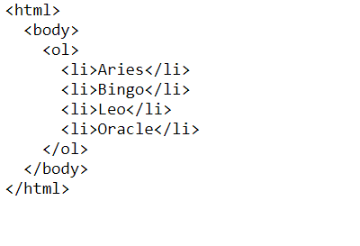

Output 1:

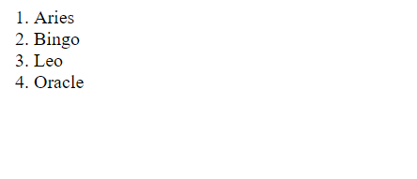

Source Code 2:

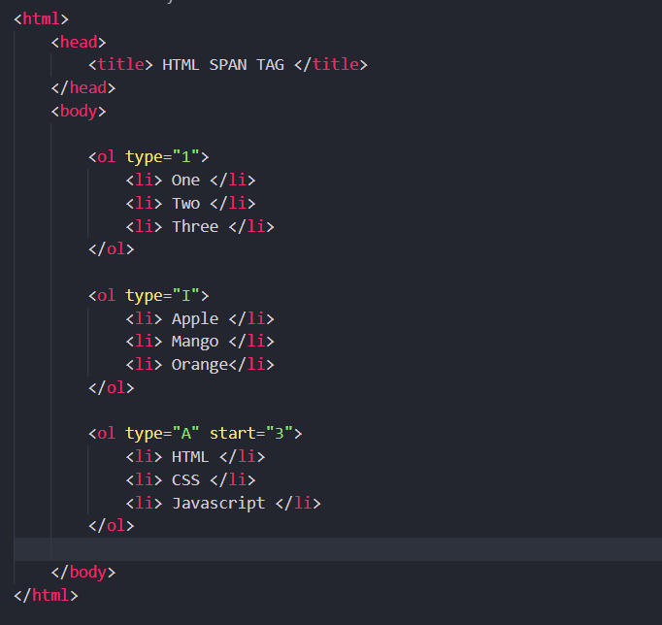

Output 2:

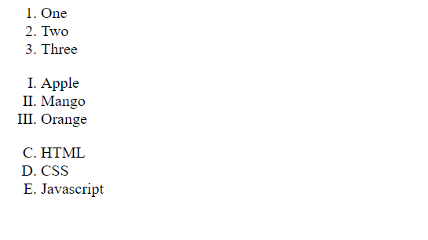

**HTML Unordered List or Bulleted List:**

In HTML Unordered list, all the list items are marked with bullets. It is also known as bulleted list also. The Unordered list starts with <ul> tag and list items start with the <li> tag.

Example:

<ul>

 <li>Aries</li>

 <li>Bingo</li>

 <li>Leo</li>

 <li>Oracle</li>

</ul>

Source Code:

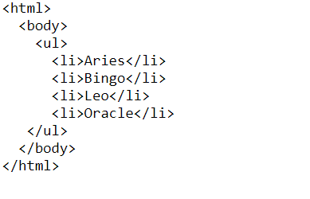

Output:

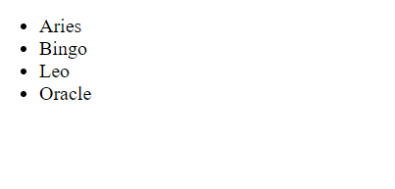

## HTML Description List or Definition List:

HTML Description list is also a list style which is supported by HTML and XHTML. It is also known as definition list where entries are listed like a dictionary or encyclopedia.

The definition list is very appropriate when you want to present glossary, list of terms or another name-value list.

The HTML definition list contains following three tags:

1. **<dl> tag** defines the start of the list.
2. **<dt> tag** defines a term.
3. **<dd> tag** defines the term definition (description).

Example:

<dl>

    <dt>Aries</dt>

  <dd>-One of the 12 horoscope sign.</dd>

    <dt>Bingo</dt>

  <dd>-One of my evening snacks</dd>

  <dt>Leo</dt>

  <dd>-It is also an one of the 12 horoscope sign.</dd>

   <dt>Oracle</dt>

   <dd>-It is a multinational technology corporation.</dd>

</dl>

## Source Code:

## 

Output:

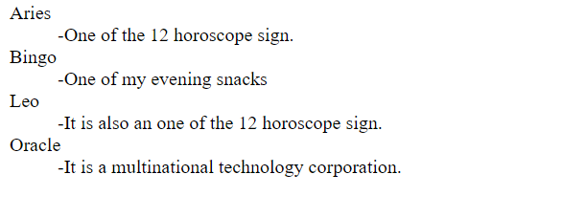

## HTML Nested List:

## A list within another list is termed as nested list. If you want a bullet list inside a numbered list then such type of list will be called as nested list.

## Source Code:

## 

Output:

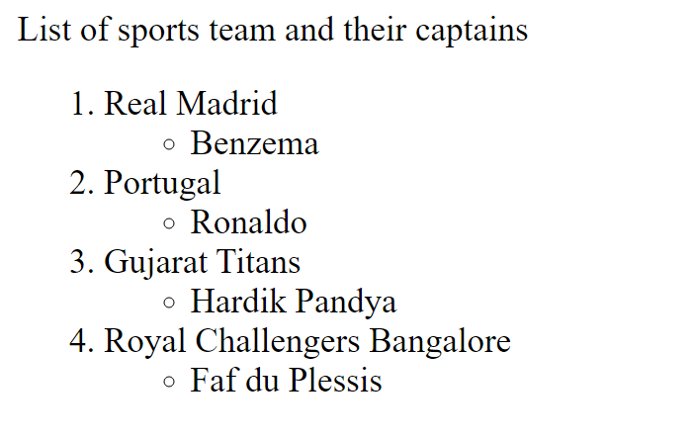

**Comments:**

Comment is a piece of code which is ignored by any web browser. It is a good practice to add comments into your HTML code, especially in complex documents, to indicate sections of a document, and any other notes to anyone looking at the code. Comments help you and others understand your code and increases code readability. You can put comments between any tags in your HTML documents.

Syntax:

<!-- comment goes here -->

Anything after <!--until the closing --> will not be displayed. It can be still seen in the source code for the document, but it is not shown on screen.

**Understanding Block and Inline Elements:**

Now that you have seen many of the elements that can be used to markup text, it is important to make an observation about all the elements that live inside the <body> element, because each one can fall into one of two categories:

* Block-level Elements
* Inline Elements
* Block-level Elements:

Block elements appear on the screen as if they have a line break before and after them. For example, the <p>, <h1>, <h2>, <h3>, <h4>, <h5>, <h6>, <ul>, <ol>, <dl>, <pre>, <hr/>, <blockquote>, <div>, <address> elements are all block level elements. They all start on their own new line, and anything that follows them appears on its own new line.

* Inline Elements:

Inline elements, on the other hand, can appear within sentences and do not have to appear on a new line of their own. The <b>, <i>, <u>, <em>, <strong>, <sup>, <sub>, <big>, <small>, <li>, <ins>, <del>, <code>, <cite>, <dfn>, <kbd>, <var>, <span>, <a> elements are all inline elements.

**For block level and inline elements write example, source code and check output on your own.**

**Grouping HTML Elements:**

There are two important tags which we use very frequently to group various other HTML tags:

* **<div> tag:**

This is very important block level tag which plays a big role in grouping various other HTML tags and applying CSS on group of elements. Even now <div> tag can be used to create webpage layout where we define different parts (Left, Right, Top etc.) of the page using <div> tag. This tag does not provide any visual change on the block but this has more meaning when it is used with CSS.

Example/Source Code:

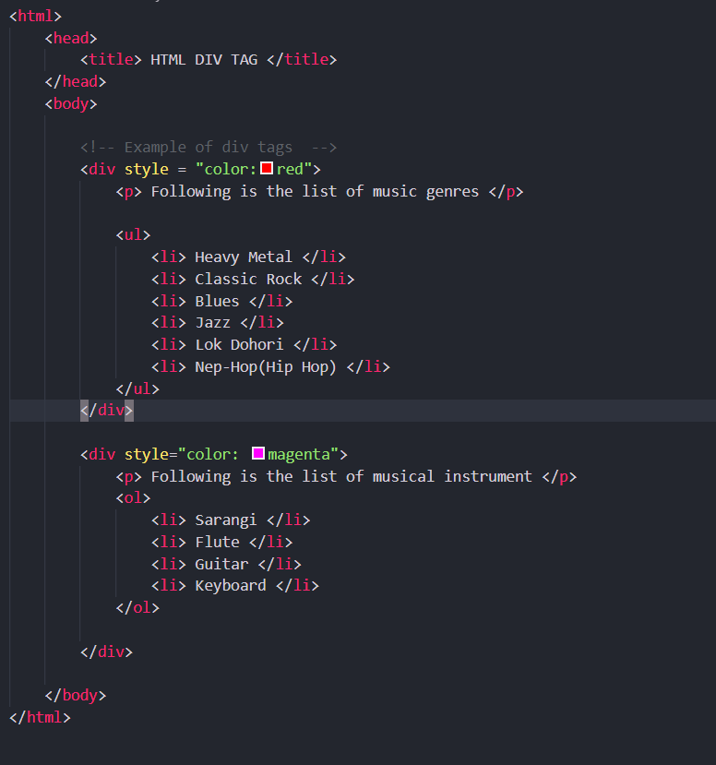

Output:

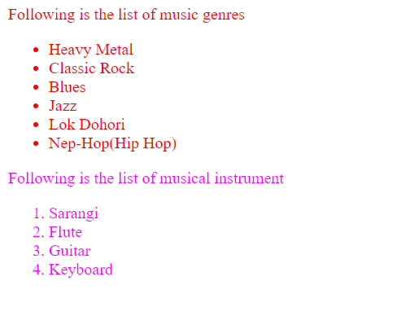

* **<span> tag:**

The HTML <span> is an inline element and it can be used to group inline-elements in an HTML document. This tag also does not provide any visual change on the block but has more meaning when it is used with CSS.

The difference between the <span> tag and the <div> tag is that the <span> tag is used with inline elements whereas the <div> tag is used with block-level elements.

Example/Source Code:

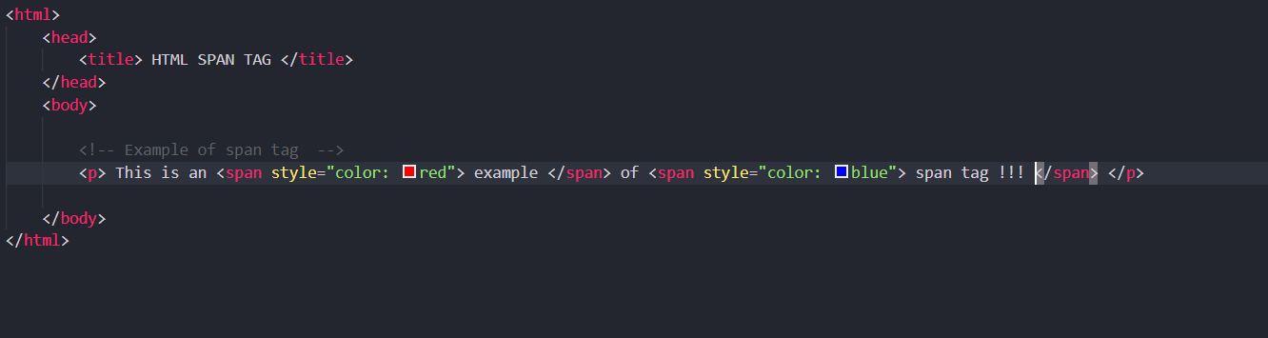

Output:

